

Wanderlust Personal Blog

Names : Rires Sutrisno (1710010085)

Syifa Sabrina (1710010096)

Class : 3SC5

CEP CCIT

FAKULTAS TEKNIK UNIVERSITAS INDONESIA

2018

**PROJECT ON**

*Wanderlust Personal Blog*

**Developed by**

1. Rires Sutrisno
2. Syifa Sabrina



**Wanderlust Personal Blog**

Batch Code : 3SC5

Start Date : October 18th, 2018

End Date : November 1st, 2018

Name of Coordinator : Fachran Nazarullah, S.Kom

Name of Developer : Rires Sutrisno

Syifa Sabrina

Date of Submission : November 2nd, 2018



**CERTIFICATE**

This is to certify that this report, titled *Wanderlust Personal Blog,* embodies the original work by **Rires Sutrisno**and**Syifa Sabrina**in partial fulfillment of his/her course requirement at NIIT.

Coordinator :

***Fachran Nazarullah, S.Kom***

**ACKNOWLEDGEMENT**

All the praises and thanks be to Allah for His guides and blesses, so that this paper entitled “Wanderlust Personal Blog” can be completed on time.

Also thanks to Mr. Fachran Nazarullah for the feedbacks and suggestions given. This paper is written to fulfil assignment and this paper has benefited a lot by the feedbacks.

And thanks for various parties, like :

1. Parents who always support through spirit or even material.
2. Dr. Muhammad Suryanegara, ST., M.Sc. as director of CEP-CCIT Faculty of Engineering, University of Indonesia.
3. Friends who give some suggestions.

Apologize if there are any mistakes in the project. Feel free to give any advice so that the project can be better in the future.

**SYSTEM ANALYSIS**

**System Summary**:

Wanderlust means a strong desire to travel. So, this blog is dedicated for people who have a similar desire to wandering and explore something new. Specifically, this blog has 3 main categories. There are food, fashion, and travel.

Wanderlust shares latest and newest update about food, fashion, and travel internationally.

**INTRODUCTION**

In this project, a personal blog is created using HTML, CSS, and jQuery. Wanderlust means a strong desire to travel. Therefore, this blog contains information about travel, food, and fashion. Besides showing a chic-look display, this personal blog also responsive to any other devices.

\

sssssssssss

**ACTIVITIES LIST**

|  |  |  |  |  |  |
| --- | --- | --- | --- | --- | --- |
| ***No.*** | ***Activity Description*** | ***Planned Date of Completion*** | ***Actual Date*** | ***Responsibility*** | ***Remarks*** |
| *1* | *Create Layout using HTML and CSS* | October 18th, 2018 | October 18th, 2018 | Rires Sutrisno and Syifa Sabrina |  |
| *2* | *Create Content and Image Web* | October 21st, 2018 | October 21st, 2018 | Rires Sutrisno and Syifa Sabrina |  |
| *3* | *Create form* | October 25th, 2018 | October 25th, 2018 | Rires Sutrisno and Syifa Sabrina |  |
| *4* | *Create JavaScript forms and perform validations* | October 31st, 2018 | October 31st, 2018 | Rires Sutrisno and Syifa Sabrina |  |
| *5* | *Create Effect using JQuery* | October 25th, 2018 | October 25th, 2018 | Rires Sutrisno and Syifa Sabrina |  |
| *6* | *Create Meta Tag* | November 1st, 2018 | November 1st, 2018 | Rires Sutrisno and Syifa Sabrina |  |
| *7* | *Create Programming for Mobile Device* | November 1st, 2018 | November 1st, 2018 | Rires Sutrisno and Syifa Sabrina |  |
| *8* | *Make a paper* | November 1st, 2018 | November 1st, 2018 | Rires Sutrisno and Syifa Sabrina |  |
| *9* | *Make a point* | November 1st, 2018 | November 1st, 2018 | Rires Sutrisno and Syifa Sabrina |  |

**HTML PAGES**

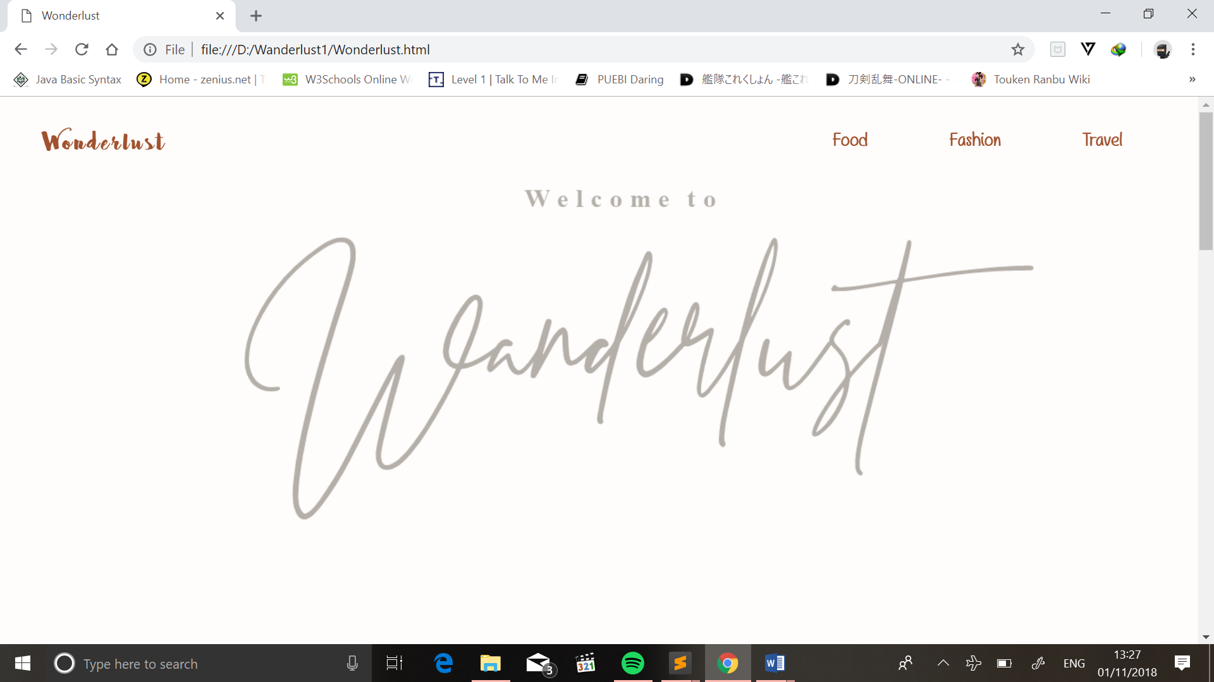

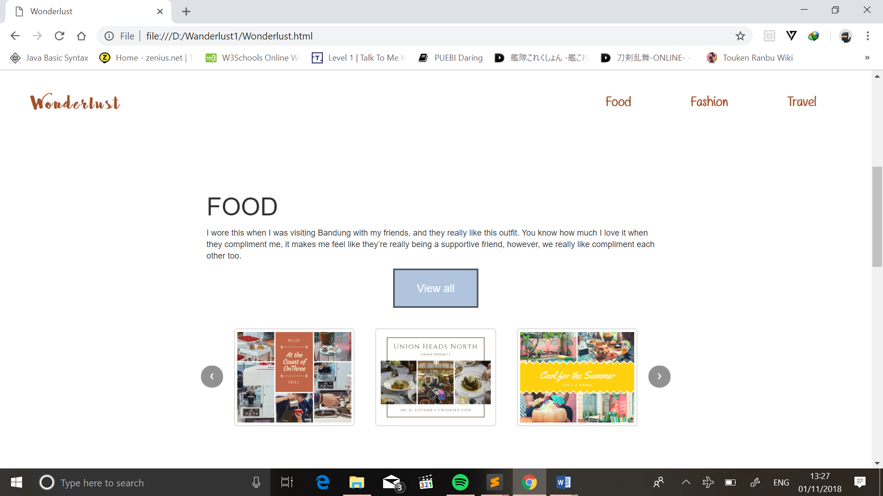

*Home page*

**HTML PAGES**

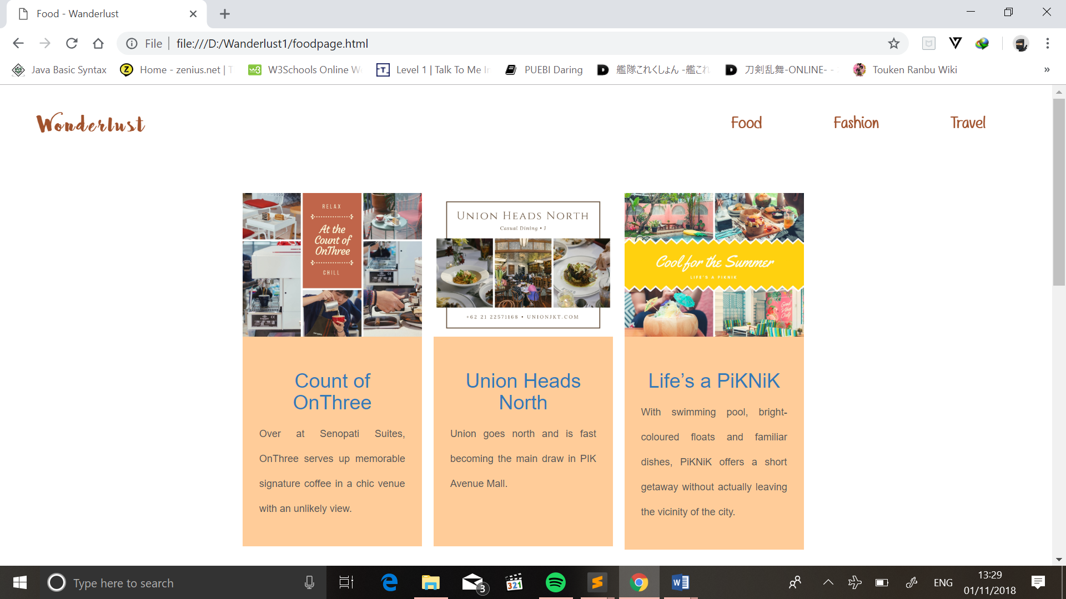

*View all page*

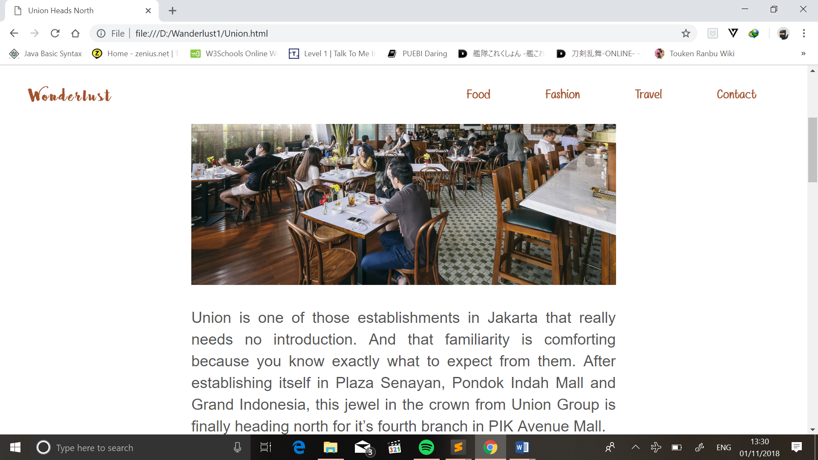

*Content page*

**CONFIGURATION**

**Hardware :** *Intel(R) Core(TM) i7-7500U CPU @ 2.70GHz, 2.90 GHz 1TB HDD+128GB SSD, ASUS VivoBook Flip 14*

**Operating System :** *Windows 10 Home Single Language*

**Software :**  Sublime Text 3.1.1, Chrome

**GitHub**: https://github.com/icecoffeejelly/Wanderlust.git

|  |  |  |
| --- | --- | --- |
| **PROJECT FILE DETAILS** | | |
| **S.No** | **File Name** | **Remarks** |
| 1 | Wanderlust | HTML, CSS, and jQuery |